**How to find your tag number**

The toll tags are used as credentials to allow through the gates. No charges will be incurred on your tag for use as an access credential. We accept two types of tags: TXTag, and TransCore eGo Plus Sticker Tag. See the following images to find your tag number.

TXTag (Tolltag)

Enter TEX.00000000

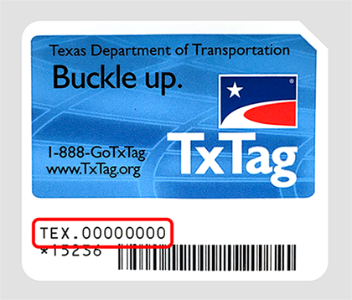

TransCore eGo Plus Sticker Tag

*TransCore eGo Plus tags must be purchased/issued from Parking Services.

 Enter 000000  
  
