**TO:** MSIII, Internal Medicine Clerkship, TTUHSC

**FROM:** Peggy Edwards, Jennifer Teichelman, Micah Walsleben, and Margaret Vugrin

Reference Librarians at TTUHSC Preston Smith Library, Lubbock, TX

Welcome to the Evidence-Based Medical Literature course of the Internal Medicine Clerkship. The learning activities will give you new and additional skills using many computer-based and smart phone apps that are Evidence-Based Medicine information resources. The library's home page is located at: http://www.ttuhsc.edu/libraries/ Links to course materials are located through the Library Courses tab below.

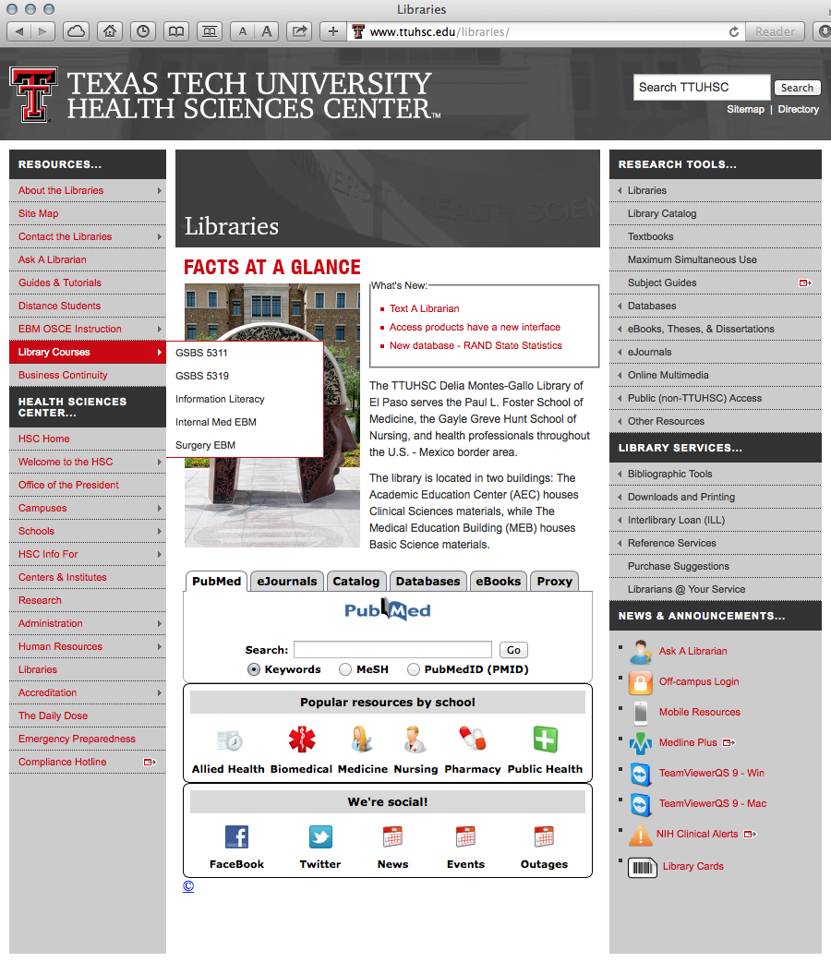

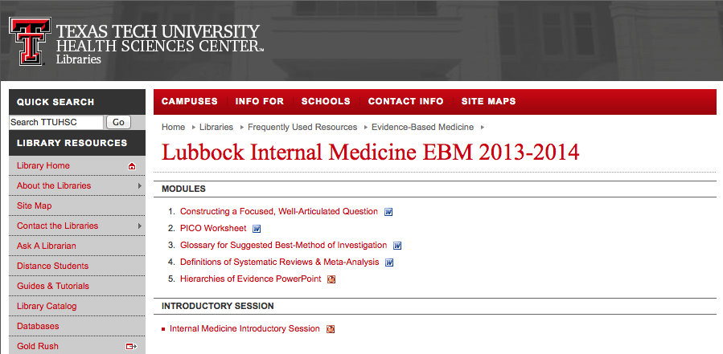

***ACTIVITIES:***

1) Identify a search question based on a patient you see during the Internal Medicine Rotation *or* any research question you have.

2) Read the documents and review the PowerPoints available through the library homepage at: http://www.ttuhsc.edu/libraries/schools/internalmedebm/

3) Read the handout below: *"Constructing a Focused, Well-Articulated Question."*

4) Complete the *PICO Worksheet.*

5) Bring a copy of the completed worksheet to the assigned one-on-one teaching session with a reference librarian.

6) Attendance dates will be emailed to you. Please contact Peggy Edwards at peggy.edwards@ttuhsc.edu if you have questions.

**Syllabus for Evidence-Based Medicine**

**MSIII Internal Medicine Clerkship, 2014 – 2015**

**Dates: Classes and Assignments Due**

**1st Tuesday of Rotation** Clerkship Orientation - Syllabus Review ***Mandatory***

**1:00-2:00 pm**  *Introductory Orientation* - Course Requirements; Internal Medicine

**LRC, Preston Smith Library** PowerPoint: *EBM Resources Course - Internal Medicine*

Class materials in *Internal Medicine Clerkship - EBM Handout*

***PubMed One-on-One Teaching Session* *Mandatory*** *PICO Question Worksheet* ***DUE - at beginning of session***

***The Teaching Session Schedule will be emailed to you. Please schedule at least 2 hours for class!!***

**Course Description**

The Evidence-Based Medicine component of the Internal Medicine clerkship is comprised ofthree sessionsincluding:

**1) an introductory orientation to four electronic point-of-care tools and several resources specific to Internal Medicine** *and*

**2) the *PubMed One-on-One Teaching Session*** *and*

***3) the Evidence-Based Medicine Searching Station during the OSCE***

Medical librarians will instruct all sessions. During the *Introductory Orientation*, students will view highlights of important features of the point-of-care tools, via a PowerPoint, and then will complete hands-on exercises utilizing these tools. This session will be partial preparation for the EBM Literature Searching Station in the OSCE. **Attendance to the Introductory Orientation is mandatory.**

***Before*** the *PubMed One-on-One Teaching Session*, students will be expected to formulate a clinical or research question into the PICO format using the PICO worksheet. The PICO question will be of the individual student’s choice. The PICO question worksheet will be due by the beginning of the student's assigned *PubMed One-on-One Teaching Session*. **This assignment is mandatory.**

In the ***PubMed One-on-One Teaching Session***, students will be led through a lecture and hands-on literature search of the complete *PubMed* database in an effort to accelerate their proficiency in locating biomedical literature, including EBM data.

During the teaching session, the student will locate journal articles that answer the question. It is recommended that at least one journal article be a study of high quality including: 1) a systematic review or meta-analysis, or 2) a randomized-controlled trial, or 3) a cohort study, or 4) a case-controlled study, or 5) a case series or case report, or 6) a practice guideline appropriate to study question category (diagnosis, therapy, etiology/harm, prognosis). **This assignment is mandatory.**

**TTUHSC-SOM Institutional Specific Objectives**

Evaluate the clinical status of patients through proficiency in clinical reasoning, including identification of clinical problems using scientific methods, data collection, hypothesis formulation, and the retrieval, management, and appropriate use of biomedical information for decision-making.

Apply evidence-based care to patients and use skilled clinical reasoning and the current state of medical art and science.

Use self-directed learning and information technology to acquire information from the basic and clinical sciences needed for patient care.

Demonstrate commitment to life-long learning, including self-directed study of basic and clinical science, critical assessment of the medical literature, and the use of evidence-based medicine.

**Required Activities**

Class attendance

PICO question, completed PICO worksheet, article(s) that answer the PICO question

OSCE Station

**Resources**

**Links to Clerkship Materials** http://www.ttuhsc.edu/libraries/schools/internalmedebm/

***Point-of-Care Tools* *via*** http://www.ttuhsc.edu/libraries **🡺 Databases Tab 🡺 Evidence Based**

1) *ACP's Smart Medicine* 2) *Clinical Key* 3) *DynaMed* 4) *Essential Evidence Plus*

**Internal Medicine Resources**

1) *Access Medicine* **🡺 eBooks Tab (in fly out) 🡺 All eBooks>>**

2) patient education materials: *Medline Plus* http://www.nlm.nih.gov/medlineplus/

3) *Medical Letter on Drugs & Therapeutics* http://m.ttuhsc.edu/resources/

3) practice guidelines at guidelines.gov

(CG 9/18/13; rev PE 6/25/14)

**Goal and Objectives for the MSIII Internal Medicine Clerkship EBM Library Course, 2014 – 2015**

**Learner's Goal:** To become familiar with the principles of Evidence-Based Practice and demonstrate utilization of evidence-based practice resources, so that current medical knowledge will be continually integrated into clinical decision-making to improve patient outcomes.

**Objectives:** As a result of the *EBM Library Course for the MSIII Internal Medicine Clerkship* and the Internal Medicine OSCE*,* participants will be able to:

1)Recognize why this course information is important

2) Recall the definition of Evidence-Based Practice

3) Recognize the 5-step process in Evidence-Based Practice

**ASSESS**

4) Identify each component of the PICO pneumonic:

P = patient, problem, population I = intervention C = comparison O = outcome

**ASK**

5) Identify and develop a well-articulated question about either patient care issues or research issues using the *PICO Worksheet*

6) Determine the study question category as either diagnosis, or therapy, or prognosis, or etiology

**ACQUIRE**

7) Search *PubMed* to locate an article or articles to answer the PICO question

**APPRAISE**

8) Recognize the concepts in the *Hierarchy of Study Designs* andthe concepts in the *Hierarchy of Levels of Evidence*

9) Differentiate between the various types of primary studies and understand how they are weighted regarding the strength of evidence in relation to freedom from bias

10) Identify a study using a method of investigation (meta-analysis/systematic review, randomized controlled trials, cohort study, case control study, case series study, or a prospective blinded comparison to a gold standard) that corresponds to the study category

11) Assess the results of the article search

**Building Focused, Well-Articulated Clinical Questions**

What makes a clinical question well built? First, the question should be directly relevant to the problems at hand. Next, the question should be phrased to facilitate searching for a precise answer. To achieve these aims, the question must be focused and well articulated for all four parts of its 'anatomy' (known as PICO):

1) the **P**atient, population or problem being addressed

What are the characteristics of the patient or population?

What is the condition or disease?

2) the **I**ntervention being considered which could include:

exposure, diagnostic test, prognostic factor, therapy, patient perception or

What do you want to do with this patient? Treat, diagnose, observe?

3) the **C**omparison intervention or exposure, when relevant

relevant most often when looking at therapy questions

What is the alternative to the intervention? Placebo, different drug, Internal Medicine?

4) the clinical **O**utcomes of interest

What are relevant clinical outcomes of interest to you and your patient?

Morbidity, death, complications?

***Asking focused, four-component questions takes practice.*** Doing it well requires that you have insight into what you do not know, coupled with curiosity and a willingness to learn. Also, knowing how questions arise, where they come from, and how to recognize and articulate them can help you refine your skills.

How do clinical questions arise? During a patient encounter, the clinician may be uncomfortable making a decision until more is known. It is recommended that you quiet your emotions while turning your implicit knowledge gaps into explicit questions.

Most clinical questions arise from the following six aspects of clinical work:

1) Clinical evidence: how to gather clinical findings properly & interpret them soundly.

2) Diagnosis: how to select and interpret diagnostic tests.

3) Prognosis: how to anticipate the patient's likely course.

4) Therapy: how to select treatments that do more good than harm.

5) Prevention: how to screen and reduce the risk for disease.

6) Education: how to teach yourself, the patient, and the family what is needed.

How can you recognize and formulate clinical questions as they occur? First, pay careful attention to the questions that spontaneously occur to you. Listen for the 'question behind the question.' Next, try saying your questions out loud or writing them down with all four components included. Then build your question in two steps, starting with the 'location,' such as 'my question is about therapy,' Ask yourself what type of clinical scenario would you like to consider:

Therapy? Prognosis? Diagnosis? Harm?

Then, articulate all four PICO components explicitly. See the example below.

What if too many questions arise? Select from the many questions the few that are most important to answer right away. Ask yourself, "What is the most important issue for this patient now? What issue should I address first? Which question, when answered, will help me most?

**PICO Example:**

**P**atient or Problem: 65-year-old man with a stroke & moderate carotid stenosis

**I**ntervention: ASA (acetylsalicylic acid)

**C**omparison Intervention: Placebo

**O**utcome: Stroke

becomes a

**Focused, Well-Built Question:**

In a 65-year-old man with a stroke and moderate carotid stenosis, can ASA decrease the risk of another stroke compared with no treatment?

**Additional Practice**

If you would like additional practice formulating articulate questions using a web tutorial go to: http://www.cebm.utoronto.ca/practise/formulate/

**Answering Clinical Questions**

After the patient care problem(s) has been articulated into a focused, well-built question, the next step is to search the literature. A variety of EBM resources will be explored in the library teaching sessions.

**Taken from:**

*The well-built clinical question: a key to evidence-based decisions* by W. Scott Richardson, MD, et al. in *ACP Journal Club*. 1995; 123 (Nov-Dec): A-12.

Centre for Evidence-Based Medicine, University Health Network, University of Toronto Libraries, (2004). *Practicing EBM*. Retrieved May 8, 2007, from *Practicing EBM: Formulating* *Answerable Clinical Questions* Web site: http://www.cebm.utoronto.ca/practise/formulate/

University of Washington Health Sciences Libraries, (1994-2007). Construct Well-Built Clinical Questions Using PICO. Retrieved May 9, 2007, from HealthLinks, Toolkits, Care Provider, Evidence Based Practice Web site: http://healthlinks.washington.edu/ebp/pico.html

**PICO Worksheet**

**Name:** ________________________________ **Date: ______________________**

**PICO Search terms (synonyms, alternate spellings, abbreviations, etc.**

**P (patient/population/problem)**

**What is the primary problem?**

**I (intervention)**

**What main intervention are you considering?**

**C (comparison)**

**What will the intervention be compared to?**

**O (outcome)**

**What are you trying to accomplish?**

**Type of Question** (circle one):

Therapy Etiology/Harm Prevention

Diagnosis Prognosis Other _________________

**Clinical Question**:

Using the above information, write a focused, well-articulated question.

_______________________________________________________________________________________

_______________________________________________________________________________________

**_______________________________________________________________________________________**

***rev. 06/2014***