**TO:** MSIII, Surgery Clerkship, TTUHSC

**FROM:** Peggy Edwards, Jennifer Yack, Micah Walsleben, and Margaret Vugrin

Reference Librarians at TTUHSC Preston Smith Library, Lubbock, TX

Welcome to the Evidence-Based Medical Literature course of the Surgery Clerkship. The learning activities will give you new and additional skills using many computer-based and smart phone apps that are Evidence-Based Medicine information resources. The library's home page is located at: http://www.ttuhsc.edu/libraries/ Links to course materials located through the Library Courses tab below.

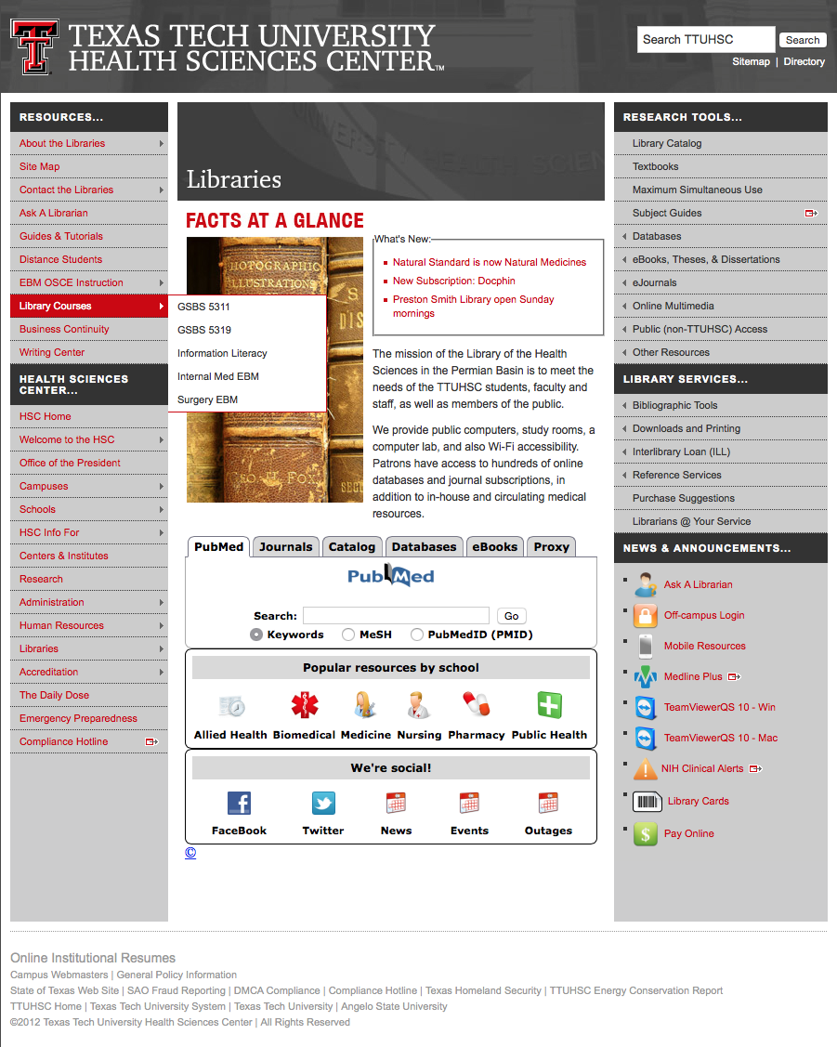

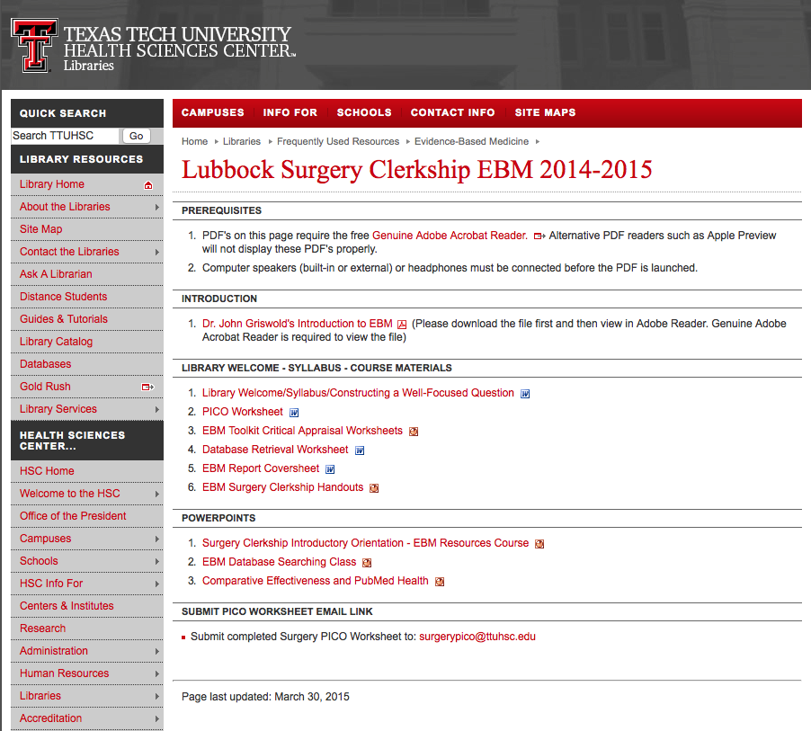

***ACTIVITIES:***

1) Identify a search question based on a patient you see during the Surgery Rotation *or* any other clinical or research question you have.

2) Read the documents and review the PowerPoints available through the library homepage at: http://www.ttuhsc.edu/libraries/schools/surgeryebm/

3) Read the handout below: *"Constructing a Focused, Well-Articulated Question."*

4) Complete the *PICO Worksheet.*

5) Email a copy of the completed worksheet to surgerypico@ttuhsc.edu so that Dr. Griswold and the reference librarians can review the PICO question.

6) Bring a copy of your completed PICO worksheet to the library for your *EBM Database Searching* class. Shae Mayes will discuss attendance dates with you.

**Syllabus for Evidence-Based Medicine**

**MSIII Surgery Clerkship, 2015 – 2016**

**Dates: Classes and Assignments Due**

**1st Monday of Rotation** Clerkship Orientation - Syllabus Review ***Mandatory***

**9:45-10:30 am**  *Surgery EBM Resources* - Course Requirements

**Surgery Offices 3A119G** PowerPoint: *EBM Resources Course* (and info re: Surgery Videos)

Class materials in *Surgery Clerkship Orientation Handbook*

**3rd Monday of Rotation** e-Mail *PICO Question Worksheet* to: ***DUE at noon***

***DUE at noon*** surgerypico@ttuhsc.edu

***CLASS 1 Mandatory***

**Date/Time: ___________** *EBM Database Searching Class* - ***Session 1***

**Library LRC**

***OR***

**Date/Time: ___________** *EBM Database Searching Class* - ***Session 2***

**Library LRC**

***CLASS 2***

**Library Rare Book Room**  Group Discussions with Dr. Griswold ***Mandatory***

**Group A: _____________** *EBM Report* ***DUE***

**Group B: _____________** *EBM Report* ***DUE***

**Course Description**

The Evidence-Based Medicine component of the surgery clerkship is comprised of **two classes**. The f**irst** is a lecture and hands-on literature search, instructed by medical librarians. In this class, students will be led through a series of databases and tools in an effort to accelerate their proficiency in locating EBM literature. Students are expected to locate at least one evidence-based article, which answers a clinical or research question of the individual student’s choice. The question can be surgical in nature, but this is not required. Formulate your clinical or research question into the PICO format on the PICO worksheet and e-mail it to Dr. Griswold and the Reference Librarians. **It is due by noon on the Monday of week 3 in your rotation.** **This assignment is mandatory.**

There will be two opportunities to take the *EBM Database Searching Class*. Session 1 will generally occur on week 4. Session 2 will generally occur on week 5. Your coordinator will ask you to select which class you wish to attend. *Consult your Night Float Schedule before you make your selection!* **Attendance to this class is mandatory.**

Students will critically appraise article(s) using a critical appraisal worksheet from the EBM Toolkit

(see Resources below), which is to be filled out and handed in at the end of your group discussion class.

There will also be two opportunities to attend the second class that is the *Group Discussion*. In this class, you will report your findings in a journal club-like atmosphere discussion led by Dr. Griswold. Group Discussion A may occur on week 4 or 5 or 6 based upon Dr. Griswold's schedule. Group Discussion B may occur on week 5 or 6 or 7, again based upon Dr. Griswold's schedule. Your coordinator will ask you to select which group discussion you wish to attend. *Consult your Night Float Schedule before you make your selection as* ***attendance is mandatory despite your call schedule****!* If you should still find yourself in a situation in which you have been on-call the previous night, you are encouraged to present first so that you may be released early. All other students are required to stay for the duration of the discussion. This is an informal presentation that does not require a PowerPoint, or handouts, etc. However, **students are expected to turn in their EBM report that includes their PICO question worksheet, critical appraisal worksheet, a copy of the article, and a cover sheet**.

**TTUHSC-SOM Institutional Specific Objectives**

Evaluate the clinical status of patients through proficiency in clinical reasoning, including identification of clinical problems using scientific methods, data collection, hypothesis formulation, and the retrieval, management, and appropriate use of biomedical information for decision-making.

Apply evidence-based care to patients and use skilled clinical reasoning and the current state of medical art and science.

Use self-directed learning and information technology to acquire information from the basic and clinical sciences needed for patient care.

Demonstrate commitment to life-long learning, including self-directed study of basic and clinical science, critical assessment of the medical literature, and the use of evidence-based medicine.

**Required Activities**

Class attendance

PICO question, completed PICO worksheet, article(s) that answer the PICO question

Critical appraisal worksheet

EBM report, including a cover sheet (name, rotation, date, PICO question, article citation, and study type)

**Resources**

***EBM Databases Available*** *via* http://www.ttuhsc.edu/libraries under databases on right side of home page

*American College of Physicians (ACP) Journal Club Cochrane Central Register of Controlled Trials*

*Cochrane Database of Systematic Reviews PubMed's Clinical Queries*

*NLM Resources for Informing Comparative Effectiveness*

***Critical Appraisal:*** *EBM Toolkit Worksheets* from the *University of Alberta* http://www.ebm.med.ualberta.ca/

**Links to Clerkship Materials** http://www.ttuhsc.edu/libraries/schools/surgeryebm/

------------------------------------------------------------------------------------------------------------------------------------------------------------

***Point-of-Care Tools* *via*** http://www.ttuhsc.edu/libraries **🡺 Databases Tab 🡺 Evidence Based**

1) *ACP's Smart Medicine* 2) *Clinical Key* 3) *DynaMed* 4) *Essential Evidence Plus*

**Surgery Resources**

1) *Access Surgery* **🡺 eBooks Tab (in fly out) 🡺 All eBooks>>**

2) *Medline Plus Videos* http://www.nlm.nih.gov/medlineplus/surgeryvideos.html

3) *Northwestern University Surgical Video Collection*

http://www.ttuhsc.edu/libraries **🡺 Online Multimedia Tab** (CG 9/18/13; rev PE 7/2/15)

**Goal and Objectives for the MSIII Surgery Clerkship EBM Library Course, 2015 – 2016**

**Learner's Goal:** To become familiar with the principles of Evidence-Based Practice, know how to utilize evidence-based practice resources, and apply critical appraisal methods to research studies reported in the medical literature, so that current medical knowledge will be continually integrated into clinical decision-making to improve patient outcomes.

**Objectives:** As a result of the *EBM Library Course for the MSIII Surgery Clerkship* and the groupdiscussion led by Dr. Griswold*,* participants will be able to:

1)Recognize why this course information is important

2) Recall the definition of Evidence-Based Practice

3) Recognize the 5-step process in Evidence-Based Practice

**ASSESS**

4) Identify each component of the PICO pneumonic:

P = patient, problem, population

I = intervention

C = comparison

O = outcome

**ASK**

5) Identify and develop a well-articulated question about either patient care issues or research issues using the *PICO Worksheet*

6) Determine the study question category as either diagnosis, or therapy, or prognosis, or etiology

**ACQUIRE**

7) Gather appropriate EBM information that answers the PICO question

8) Locate an article that answers the PICO question by searching the following:

**available through *OVID:***

*EBM Reviews - ACP Journal Club*, *EBM Reviews - Cochrane Central Register of Controlled* *Trials*,

and *EBM Reviews - Cochrane Database of Systematic Reviews*

**available through *NLM*:**

*PubMed's Clinical Queries* and *NLM Resources for Informing Comparative Effectiveness*

**APPRAISE**

9) Recognize the concepts in the *Hierarchy of Study Designs*

10) Recognize the concepts in the *Hierarchy of Levels of Evidence*

11) Differentiate between the various types of primary studies and understand how they are weighted regarding the strength of evidence in relation to freedom from bias

12) Identify a study that uses a method of investigation (randomized controlled trials, cohort study, case control study, case series study, or a prospective blinded comparison to a gold standard) that corresponds to the study category

13) Critically appraise the quality of the identified article that answers the PICO question, using the *EBM Toolkit Critical Appraisal Worksheets* from http://www.ebm.med.ualberta.ca

14) Analyze, critique and assess results of article search

**APPLY and EVALUATE**

15) Present PICO question and critically appraised article in Dr. Griswold's *Group Discussion*

16) Summarize and explain the retrieved information to Dr. Griswold and student peers

17) Validate the application of the results to a particular patient

18) Use the methods and understand the reasons for:

integrating the evidence with their clinical expertise

communicating the information to the patient

involving the patient in the decision making

applying the evidence in the context of the patient's values

transferring knowledge of EBM to their every day practice of medicine

sharing evidence effectively with their peers

judging from information found whether this would change the way they practice medicine

**Building Focused, Well-Articulated Clinical Questions**

What makes a clinical question well built? First, the question should be directly relevant to the problems at hand. Next, the question should be phrased to facilitate searching for a precise answer. To achieve these aims, the question must be focused and well articulated for all 4 parts of its 'anatomy' (known as PICO):

1) the **P**atient, population or problem being addressed

What are the characteristics of the patient or population?

What is the condition or disease?

2) the **I**ntervention being considered which could include:

exposure, diagnostic test, prognostic factor, therapy, patient perception or

What do you want to do with this patient? Treat, diagnose, observe?

3) the **C**omparison intervention or exposure, when relevant

relevant most often when looking at therapy questions

What is the alternative to the intervention? Placebo, different drug, surgery?

4) the clinical **O**utcomes of interest

What are relevant clinical outcomes of interest to you and your patient?

Morbidity, death, complications?

Asking focused, four-component questions takes practice. Doing it well requires that you have insight into what you do not know, coupled with curiosity and a willingness to learn. Also, knowing how questions arise, where they come from, and how to recognize and articulate them can help you refine your skills.

How do clinical questions arise? During a patient encounter, the clinician may be uncomfortable making a decision until more is known. It is recommended that you quiet your emotions while turning your implicit knowledge gaps into explicit questions.

Most clinical questions arise from the following six aspects of clinical work:

1) Clinical evidence: how to gather clinical findings properly & interpret them soundly.

2) Diagnosis: how to select and interpret diagnostic tests.

3) Prognosis: how to anticipate the patient's likely course.

4) Therapy: how to select treatments that do more good than harm.

5) Prevention: how to screen and reduce the risk for disease.

6) Education: how to teach yourself, the patient, and the family what is needed.

How can you recognize and formulate clinical questions as they occur? First, pay careful attention to the questions that spontaneously occur to you. Listen for the 'question behind the question.' Next, try saying your questions out loud or writing them down with all four components included. Then build your question in two steps, starting with the 'location,' such as 'my question is about therapy,' Ask yourself what type of clinical scenario would you like to consider: Therapy? Prognosis? Diagnosis? Harm?

Then, articulate all four PICO components explicitly. See the example below.

What if too many questions arise? Select from the many questions the few that are most important to answer right away. Ask yourself, "What is the most important issue for this patient now? What issue should I address first? Which question, when answered, will help me most?

**PICO Example:**

**P**atient or Problem: 65-year-old man with a stroke & moderate carotid stenosis

**I**ntervention: ASA (acetylsalicylic acid)

**C**omparison Intervention: Placebo

**O**utcome: Stroke

becomes a

**Focused, Well-Built Question:**

In a 65-year-old man with a stroke and moderate carotid stenosis, can ASA decrease the risk of another stroke compared with no treatment?

**Additional Practice**

If you would like additional practice formulating articulate questions using a web tutorial go to: http://www.cebm.utoronto.ca/practise/formulate/

**Answering Clinical Questions**

After the patient care problem(s) has been articulated into a focused, well-built question, the next step is to search the literature. A variety of EBM resources will be explored in the library teaching sessions.

**Taken from:**

*The well-built clinical question: a key to evidence-based decisions* by W. Scott Richardson, MD, et al. in *ACP Journal Club*. 1995; 123 (Nov-Dec): A-12.

Centre for Evidence-Based Medicine, University Health Network, University of Toronto Libraries, (2004). *Practicing EBM*. Retrieved May 8, 2007, from *Practicing EBM: Formulating*

*Answerable Clinical Questions* Web site: http://www.cebm.utoronto.ca/practise/formulate/

University of Washington Health Sciences Libraries, (1994-2007). Construct Well-Built Clinical Questions Using PICO. Retrieved May 9, 2007, from HealthLinks, Toolkits, Care Provider, Evidence Based Practice Web site: http://healthlinks.washington.edu/ebp/pico.html

**PICO Worksheet**

**Name:** ________________________________ **Date: ______________________**

**PICO Search terms (synonyms, alternate spellings, abbreviations, etc.**

**P (patient/population/problem)**

**What is the primary problem?**

**I (intervention)**

**What main intervention are you considering?**

**C (comparison)**

**What will the intervention be compared to?**

**O (outcome)**

**What are you trying to accomplish?**

**Type of Question** (circle one):

Therapy Etiology/Harm Prevention

Diagnosis Prognosis Other _________________

**Clinical Question**:

Using the above information, write a focused, well-articulated question.

_______________________________________________________________________________________

_______________________________________________________________________________________

***************************************************************************************

**4) *Attention!*** *Please email a copy of the completed worksheet to:*

surgerypico@ttuhsc.edu

***rev.7 07/2014*5**

Evidence Based Medicine Report

MSIII Surgery Clerkship

Name:

Date:

Rotation:

Include:

____ PICO Question Worksheet

____ Copy of Journal Article *(or if over 5 pages, the structured abstract)*

____ EBM ToolKit Critical Appraisal Worksheet

MSIII Surgery Clerkship

Library EBM Course - Grade Checklist

Student:

Rotation Date:

**1)** *Introduction to the EBM Library Course* - Clerkship Orientation _____ YES _____ NO

Date: Sign-In Sheet _____

**2)** Completed *PICO Question Worksheet* in *EBM Report* _____YES _____ NO

**3)** *EBM Database Searching Class* _____ YES _____ NO

Date: Sign-In Sheet _____

**4)** Copy of Journal Article in *EBM Report* _____ YES _____ NO

(or if over 5 pages, the structured abstract)

**5)** *EBM ToolKit Critical Appraisal Worksheet* with notations as appropriate ______ YES _____ NO

**6)** Dr. Griswold's *Group Discussion Class*

Date: Sign-In Sheet _____ ______ YES _____ NO

**7)** *EBM Report* Completed and Handed-in ______YES ______ NO

**8)** Professionalism:

Displays excellent work ethic and is reliable _____ YES _____ NO

Is conscientious in increasing knowledge and skills _____ YES _____ NO

Completes assignments in a timely manner _____ YES _____ NO

*(See back page for any notes.)*

Librarian: _________________________________ Date: __________________ 7/2/15 pe