Memo
TO: MSIII, Internal Medicine Clerkship, TTUHSC
FROM: Peggy Edwards, Carrie Gassett, Dawn Kruse, and Margaret Vugrin
Reference Librarians at TTUHSC Preston Smith Library

Welcome to the Evidence-Based Medical Literature component of the Internal Medicine clerkship. The learning activities will give you new and additional skills using many computer-based and PDA-based Evidence-Based Medicine information resources.

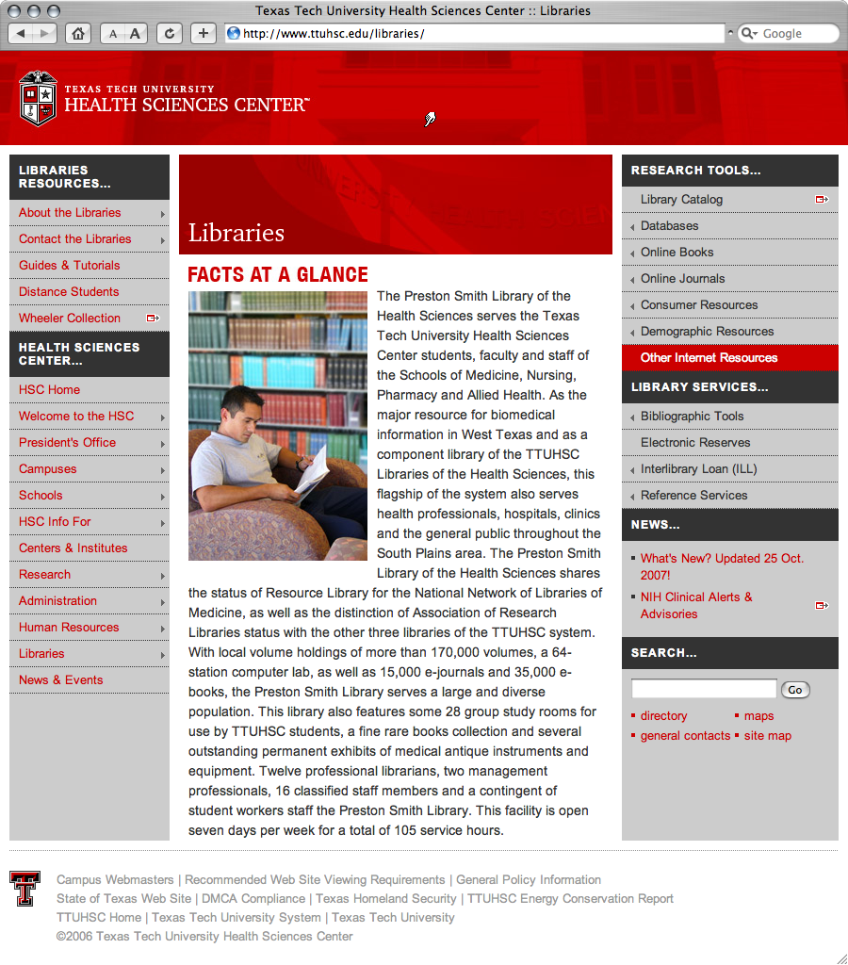

ACTIVITIES:
1) Identify a search question based on a patient you see during the Internal
Medicine Rotation.

2) Review the handout "Constructing a Focused, Well-Articulated Question."

3) Complete the PICO Worksheet.

4) Bring your completed PICO worksheet to the library for your one-on-one teaching
session. Colleen Sims has the time, date, place, & name of the librarian to
which you have been assigned.

OSCE:
There is an evidence-based medicine resources test station in the OSCE. There will be a total of 30 minutes spent at the EBM station. You will spend 20 minutes searching an assigned clinical question. The next 10 minutes will be spent with a librarian evaluating the information you have found on one or more of the following foreground information point-of-care databases:
ACP's PIER
Dynamed
FirstConsult
Essential Evidence Plus
PubMed (using MeSH)
You may also want to use the National Guideline Clearinghouse at www.guideline.gov and/or PubMed.

Building Focused, Well-Articulated Clinical Questions

What makes a clinical question well built? First, the question should be directly relevant to the problems at hand. Next, the question should be phrased to facilitate
searching for a precise answer. To achieve these aims, the question must be focused
and well articulated for all 4 parts of its 'anatomy' (known as PICO):

1) the Patient, population or problem being addressed
What are the characteristics of the patient or population?
What is the condition or disease?
2) the Intervention being considered which could include:
exposure, diagnostic test, prognostic factor, therapy, patient perception or
What do you want to do with this patient? Treat, diagnose, observe?
3) the Comparison intervention or exposure, when relevant
relevant most often when looking at therapy questions
What is the alternative to the intervention? Placebo, different drug, surgery?
4) the clinical Outcomes of interest
What are relevant clinical outcomes of interest to you and your patient?
Morbidity, death, complications?

Asking focused, four-component questions takes practice. Doing it well requires that you have insight into what you do not know, coupled with curiosity and a willingness to learn. Also, knowing how questions arise, where they come from, and how to recognize and articulate them can help you refine your skills.
How do clinical questions arise? During a patient encounter, the clinician may be uncomfortable making a decision until more is known. It is recommended that you quiet
your emotions while turning your implicit knowledge gaps into explicit questions.
Most clinical questions arise from the following six aspects of clinical work:

1) Clinical evidence: how to gather clinical findings properly & interpret them soundly.
2) Diagnosis: how to select and interpret diagnostic tests.
3) Prognosis: how to anticipate the patient's likely course.
4) Therapy: how to select treatments that do more good than harm.
5) Prevention: how to screen and reduce the risk for disease.
6) Education: how to teach yourself, the patient, and the family what is needed.

How can you recognize and formulate clinical questions as they occur? First, pay careful attention to the questions that spontaneously occur to you. Listen for the 'question behind the question.' Next, try saying your questions out loud or writing them down with all four components included. Then build your question in two steps, starting with the 'location,' such as 'my question is about therapy,' Ask yourself what type of clinical scenario would you like to consider: Therapy? Prognosis? Diagnosis? Harm?
Then, articulate all four PICO components explicitly. See the example below.
What if too many questions arise? Select from the many questions the few that are most important to answer right away. Ask yourself, "What is the most important issue for this patient now? What issue should I address first? Which question, when answered, will help me most?
PICO Example:
Patient or Problem: 65-year-old man with a stroke & moderate carotid stenosis
Intervention: ASA (acetylsalicylic acid)
Comparison Intervention: Placebo
Outcome: Stroke
becomes a
Focused, Well-Built Question:
In a 65-year-old man with a stroke and moderate carotid stenosis, can ASA decrease the risk of another stroke compared with no treatment?
Additional Practice
If you would like additional practice formulating articulate questions using a web tutorial go to: http://www.cebm.utoronto.ca/practise/formulate/
Answering Clinical Questions
After the patient care problem(s) has been articulated into a focused, well-built question, the next step is to search the literature. A variety of EBM resources will be
explored in the library teaching sessions.
Taken from:
The well-built clinical question: a key to evidence-based decisions by W. Scott Richardson, MD, et al. in ACP Journal Club. 1995; 123 (Nov-Dec): A-12.

Centre for Evidence-Based Medicine, University Health Network, University of Toronto Libraries, (2004). Practising EBM. Retrieved May 8, 2007, from Practising EBM: Formulating
Answerable Clinical Questions Web site: http://www.cebm.utoronto.ca/practise/formulate/

University of Washington Health Sciences Libraries, (1994-2007). Construct Well-Built Clinical Questions Using PICO. Retrieved May 9, 2007, from HealthLinks, Toolkits, Care Provider, Evidence Based Practice Web site: http://healthlinks.washington.edu/ebp/pico.html
rev.3 04/15/10

PICO Worksheet

Name: Date:
___________________________________________________________________

Clinical Question:

Study category: therapy diagnosis harm prognosis

PICO:

Patient, population, or problem being addressed
What are the characteristics of the patient or population?
What is the condition or disease?

Intervention being considered which could include:
exposure, diagnostic test, prognostic factor, therapy, patient perception
What do you want to do with this patient? Treat, diagnose, observe?

Comparison intervention or exposure
Relevant most often when looking at therapy questions.
What is the alternative to the intervention? Placebo, different drug, surgery?

Outcomes of interest
What are the relevant clinical outcomes of interest to you and your patient?
Morbidity, death, complications?

Focused, Well-Built Question:

