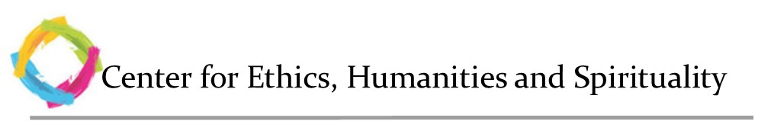

**APPLICATION**

Your Name:\_\_\_\_\_\_\_\_\_\_\_\_\_\_\_\_\_\_\_\_\_\_\_\_\_\_\_\_\_\_\_\_\_\_

Address: \_\_\_\_\_\_\_\_\_\_\_\_\_\_\_\_\_\_\_\_\_\_\_\_\_\_\_\_\_\_\_\_\_\_\_

Telephone Contact: \_\_\_\_\_\_\_\_\_\_\_\_\_\_\_\_\_\_\_\_\_\_\_\_\_\_\_\_

Email Address: \_\_\_\_\_\_\_\_\_\_\_\_\_\_\_\_\_\_\_\_\_\_\_\_\_\_\_\_\_\_\_

In order to apply for this Certificate Program, submit a separate document briefly describing your interest in the Medical Humanities. Include any background you bring, and what you hope to get out of this program. Attach response with this form and submit to the following:

*Dr. Cheryl Erwin, Director*

*5B101*

*806-743-6772*

*Or:*

*Email: Joanna.franks@ttuhsc.edu*

*806-743-4062*

Once submitted, your application will be reviewed by the Program Director. If a student is accepted into the program, you will receive an email from the Center. Please note that a maximum of 30 students will be enrolled in the MHCP at any one time. You are encouraged to apply early.

C:\Users\raforbes\AppData\Local\Microsoft\Windows\Temporary Internet Files\Content.Word\TTUHSC_DblT_SoM_c2C.TIF