**SAMPLE “Certificate Preparation” page for Physicians (MDs or DOs)** – AMA PRA Category 1 CreditTM

This is after the evaluation is completed and prior to printing certificate

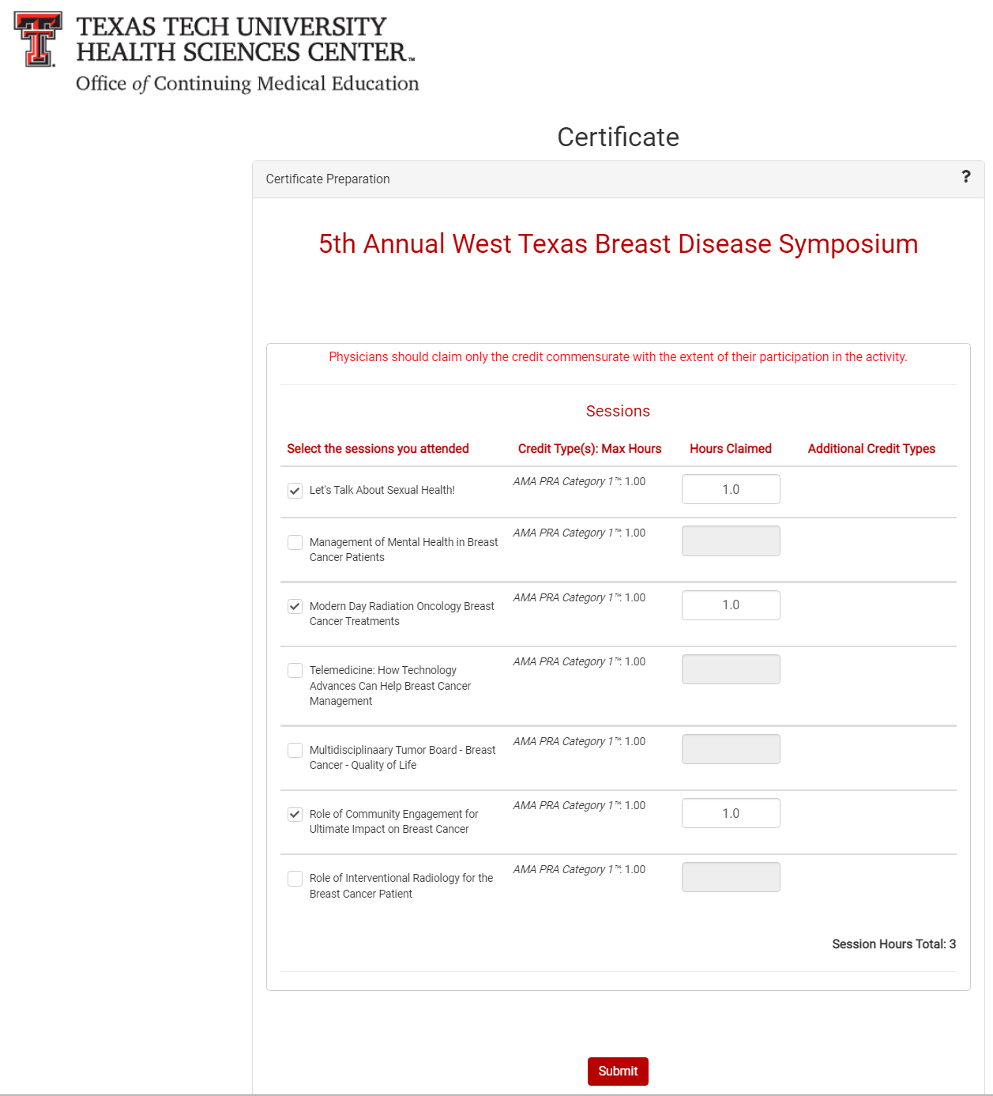

SAMPLE

**SAMPLE “Certificate Preparation” page for Non-Physicians – Attendance Credit**

This is after the evaluation is completed and prior to printing certificate

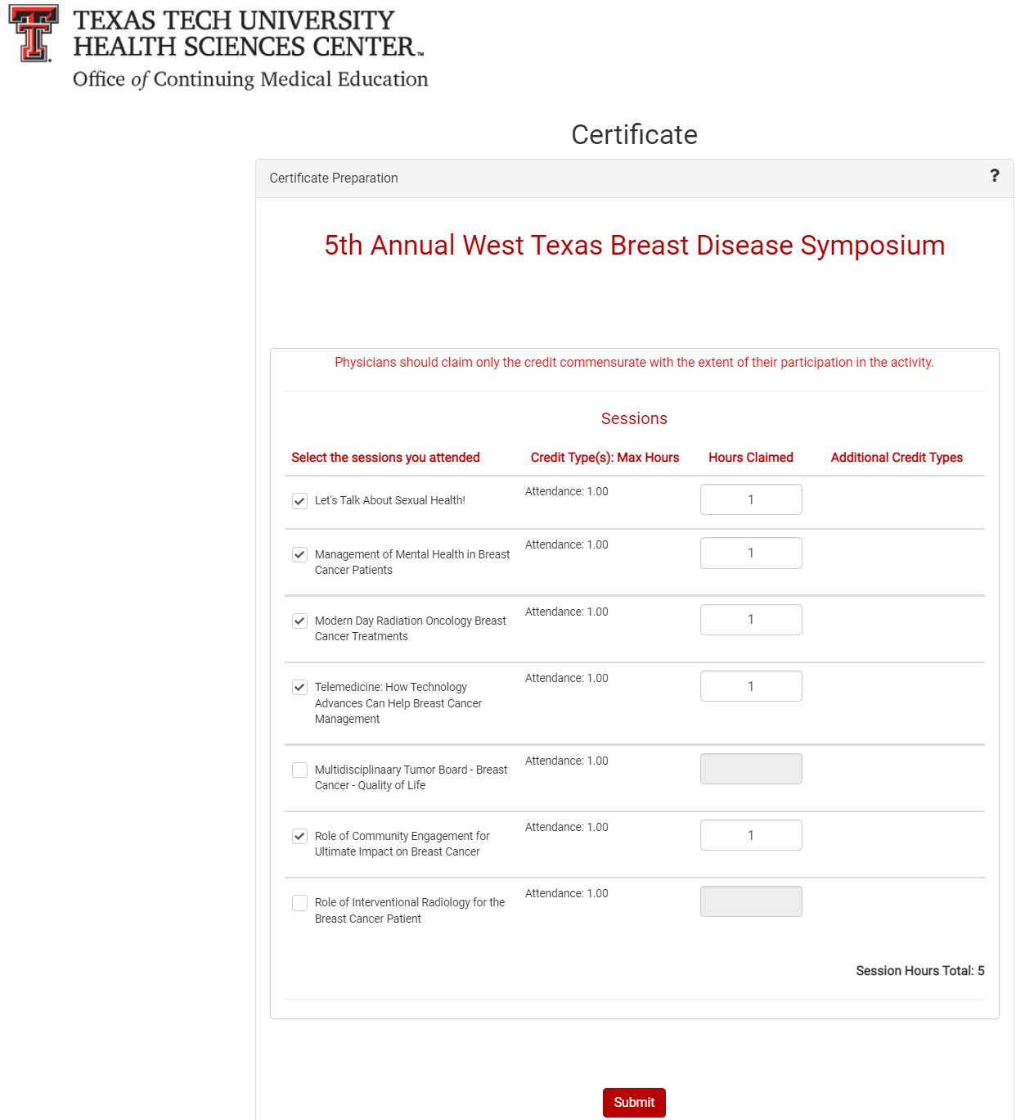

SAMPLE