HC


ANNUAL OPHTHALMIC
TECHNICIAN SEMINAR
October 26, 2018

Texas Tech University Health Sciences Center
Academic Classroom Building Room 110
3601 4th Street Room
Lubbock, Texas 79430

Accrue Up To 5 JCAHPO Continuing Education Credits
Sponsored by
The Department of Ophthalmology & Visual Sciences

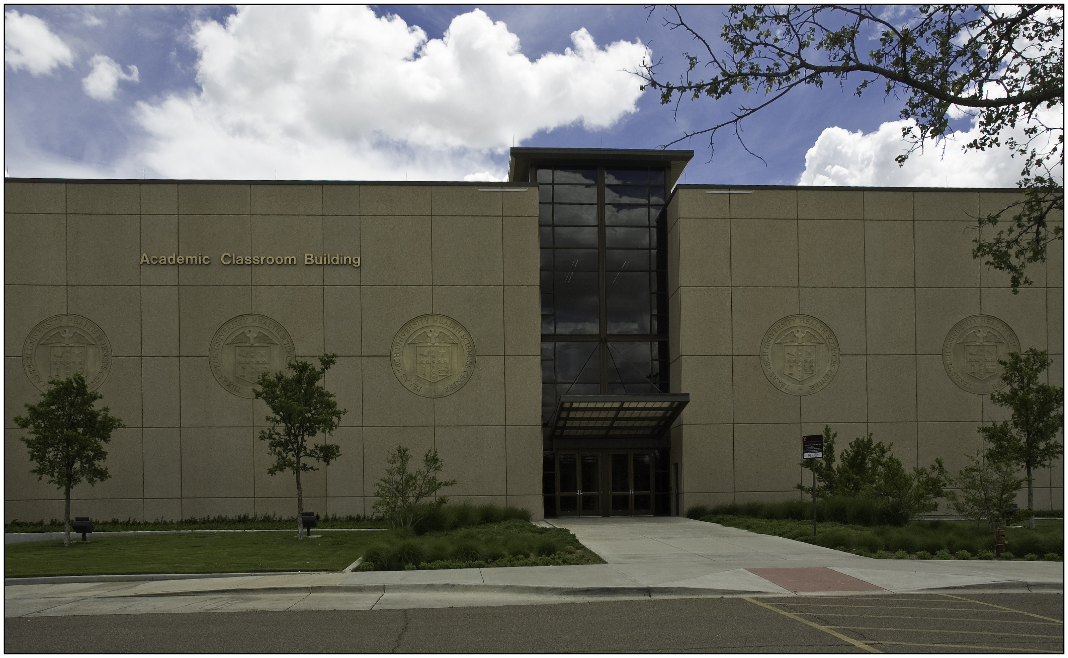

ANNUAL OPHTHALMIC TECHNICIAN/ASSISTANT SEMINAR AGENDA
Friday, October 26, 2018 Academic Classroom Building Room 110
7:30 a.m. – 4:00 p.m.

7:30 a.m. – 8:00 a.m. Registration and Breakfast

8:00 a.m. – 8:15 a.m. Welcome and Opening Remarks
Sandra Owen – Sr. Clinical Department Administrator

8:15 a.m. – 9:15 a.m. “Trauma, Trauma”
James Lee, MD, Assistant Professor - TTUHSC

9:15 a.m. – 10:15 a.m. “Understanding Uveitis:”
Kelly Mitchell, MD, Associate Professor - TTUHSC

10:15 a.m. – 10:30 a.m. Morning Refreshment Break

10:30 a.m. – 11:30 a.m. “Dry Eye’s, OH MY”
Charles Stockwell, OD, Faculty Associate - TTUHSC

11:30 p.m. – 12:30 p.m. Lunch Break

12:30 p.m. – 1:30 p.m. “Current Research Trends in Ophthalmology”
Ted Reid, PhD, Professor – TTUHSC

1:30 p.m. – 1:45 p.m. Afternoon Refreshment Break

1:45 p.m. –2:45 p.m. “Medical & Surgical Eyelid Problems”
Ken Freedman, MD, PhD, Associate Professor - TTUHSC

2:45 p.m. – 3:45 p.m. “Contact Lens Update & Review”
Matthew Mahek, OD, Faculty Associate – TTUHSC

3:45 p.m. – 4:00 p.m. Closing Remarks and Seminar Evaluations

DISCLAIMER

The courses presented at this seminar are not sponsored by JCAHPO; only reviewed for compliance with JCAHPO standards and criteria and awarded continuing education credit accordingly; therefore, JCAHPO cannot predict the effectiveness of the program or assure is quality in substance and presentation.

COURSE DESCRIPTIONS

Trauma, Trauma:
This one-hour course will discuss how trauma can cause a wide range of ophthalmic pathology and start a condition that is the consequence of a previous disease or injury.

Understanding Uveitis:
This one-hour course will discuss how uveitis as a subspecialty or fellowship arear of ophthalmology that focuses on the evaluation and treatment of ocular disease where inflammation causes the major problems.

Dry Eye’s, OH MY:
This one-hour course will describe symptoms of dry eye’s and ocular surface irritants. It will look at prevalence, identification, progression and management, along with follow-up.

Current Research Trends in Ophthalmology:
This one-hour course will discuss the anatomy of the eye in relation to increased ocular pressure (IOP) and what might the possible reasons be that lead to blindness. It will look at how research is hoping to lead to new treatments.

Medical and Surgical Eyelid Problems:
This one-hour course will discuss medical and surgical eyelid problems along with an overview of common eyelid conditions including recognizing the clinical signs and basics of management.

Contact Lens Update and Review:
This one-hour course will discuss how contact lenses can be used in a variety of ways to improve vision and treat ocular diseases. It will also review the uses and complications of abuse and look at new advances.

Annual Ophthalmic Technician Seminar
TTUHSC Lubbock Academic Classroom Building Room 110
Friday, October 26, 2018

Registration - $80 per attendee
To register, please go to:
www.ttuhsc.edu/medicine/ophthalmology/continuing_education.aspx.
You may pay by check or credit card (Visa, MasterCard, or Discover).
Pre-registration by Monday, October 22, 2018, is preferred to ensure catering counts, but walk-ins will be welcomed. Persons with disabilities who may need auxiliary aids or services are requested to contact Terry Arranaga at terry.arranaga@ttuhsc.edu or 806.743.9972. If request is not received at least one week prior to the program date, individuals are responsible for their own auxiliary aids or services.

Breakfast and lunch will be provided.
Handouts will be available online before, during, and after the conference.

Confirmation
Registration confirmation packet will be emailed to each pre-registrant and will include:
- Registration confirmation letter
- Hotel information
- Parking, driving, and maps to TTUHSC

Cancellation Policy
Refund of registration fee, less a $25 administrative fee, will be granted if written request is received by Wednesday, October 24, 2018. Refunds will not be made for cancellations after this date.
Refunds will be made by check and can take up to 7 to 10 business days to process.

Guest Wireless
TTUHSC offers guest wireless internet access which may work better on a laptop or tablet than on mobile phone in the meeting room.

PREREGISTRATION
DEADLINE:

Wednesday
October 24, 2018

Please make check payable to “TTUHSC - Ophthalmology”

Mail to:

Texas Tech University
Health Sciences Center
Ophthalmology & Visual Sciences
Attn: Terry Arranaga
3601 4th Street MS 7217
Lubbock, Texas 79430

GENERAL INFORMATION

SEMINAR INFORMATION
- Seminar dress is business casual.
- Attendees are encouraged to bring a jacket or sweater for comfort during the meeting.

- Parking is available in front of the Academic Classroom Building the day of the seminar.
- If you have any questions regarding this seminar please contact Terry Arranaga, Seminar Coordinator, at 806.743.9972 or terry.arranaga@ttuhsc.edu

CONTINUING EDUCATION CREDITS
- This program has approval of up to 5.0 Group A JCAHPO continuing education credits.
- The certificate of your earned credits from this seminar will be mailed to you with in 2-3 weeks following the seminar.
- NOTE: Attendance is monitored for each hour of instruction. Participants absent for more than 15 minutes of any given hour will not receive credit for that hour.
HOTEL
There is a room block for this Seminar at the Staybridge Suites Hotel for $89.00 per night plus applicable taxes.

Staybridge Suites
2515 19th Street Lubbock, Texas 79410
806.765.8900
Please ask for the “Technician Seminar Room Block” when you call to make your reservation.

Please Remember:
- Book your room as early as possible since there are a limited number of rooms in the room block.
- Rooms outside of the room block or rooms at other hotels cannot be guaranteed due to other events scheduled in Lubbock during the same week as this seminar.

Staybridge is conveniently located near the TTUHSC campus, with several restaurants nearby, including: Café J, McAlister’s Deli and many others.

Please visit our website for additional information:
www.ttuhsc.edu/medicine/ophthalmology/

3601 4th Street STOP 7217
Lubbock, Texas 79430-7217

RETURN SERVICE REQUESTED

IMPORTANT INFORMATION REGARDING:
Continuing Education for COA, COT Certified and Non-certified Technicians

