**First Annual Ketner Lectureship: Healthcare Evolution**

**October 2018**

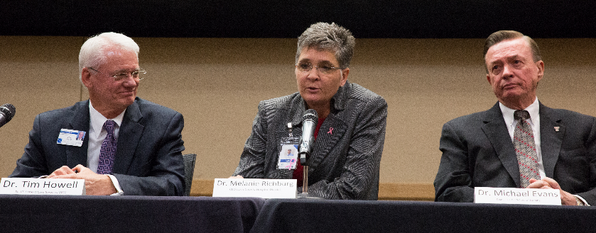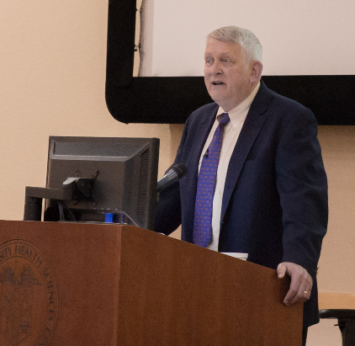The Office of Research and Scholarship hosted the First Annual Ketner Lectureship, featuring guest lecturer Dr. Jeffrey Bauer. His presentation was titled “Healthcare Evolution: Forecasting the Evolutionary Futures of Health Care: Thinking Beyond Today.” Dr. Bauer is an internationally recognized health futurist and medical economist. As an independent industry thought leader, he forecasts the evolution of health care and develops practical approaches to improving the medical sector of the American economy. He is widely known for his specific proposals to create efficient, effective health care though multi-stakeholder partnerships and other initiatives focused in the private sector. His presentation focused on the science of predicting and the art of forecasting the climate of healthcare. He also focused on strategic responses for the nursing profession. His specific discussion topics included: how to look at the futures (trend-based predicting vs. possibility-driven forecasting) and health care reform; forecasts for difference outcomes (the end of one-size-fits-all); scientific, technological, economic, and political forces defining health care’s possibilities; and imperatives for efficiency (no waste) and effectiveness (acceptable performance) to reinvent health care. Panel members included Dr. Tedd Mitchell, Dr. Michael Evans, Dr. Melanie Richburg, Dr. Tim Howell, and Dr. Mary Madeline Rogge. They answered audience questions related to healthcare changes that would affect West Texans.

Pictured from left to right: Dr. Tim Howell, Dr. Melanie Richburg, and Dr. Michael Evans

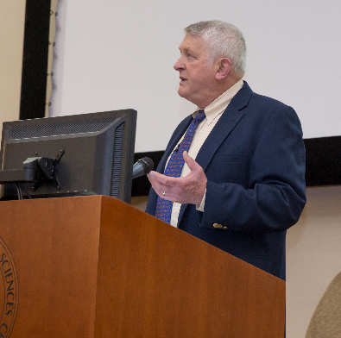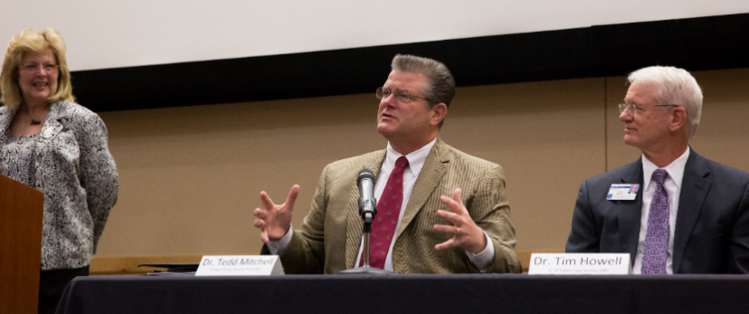

Pictured: Dr. Jeffrey Bauer

Pictured from left to right: Dr. Alyce Ashcraft, Dr. Tedd Mitchell, and Dr. Tim Howell

Pictured: Dr. Jeffrey Bauer