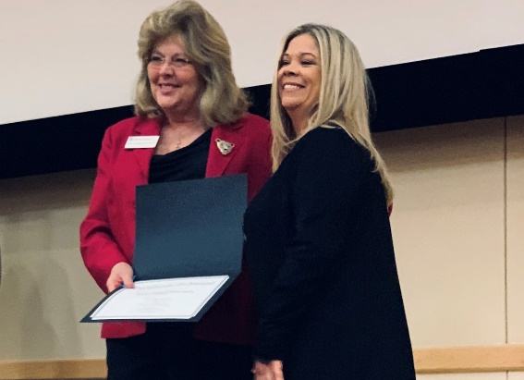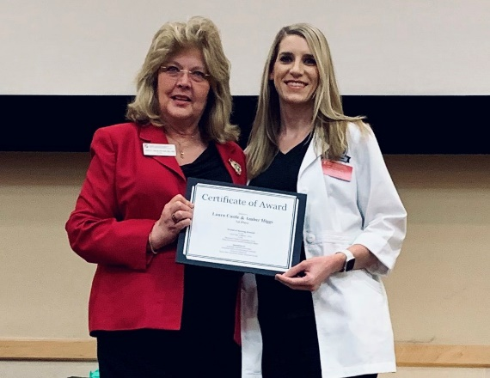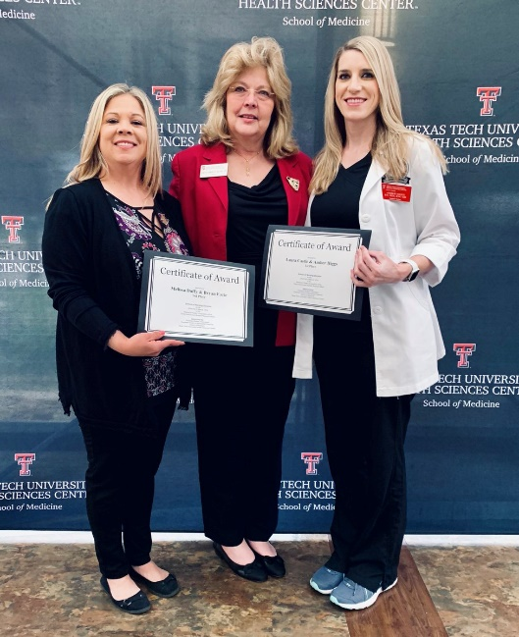**Student Research Week 2019**

Pictured: Dr. Alyce Ashcraft & Melissa Duffy

Pictured: Dr. Alyce Ashcraft & Laura Castle

Pictured: Melissa Duffy, Dr. Alyce Ashcraft, & Laura Castle

**Congratulations to Award Winners from the School of Nursing!**

**1st Place: Laura Castle and Amber Higgs**

Title of Poster: Inhaled Corticosteroids use in Pregnancy

**2nd Place: Dina Brown, BSN, RN**

Title of Poster: A Comparison of Attention Deficit-Hyperactive Disorder (ADHD) Interventions in Children Ages 6-12

**3rd Place: Melissa Duffy, BSN, RN and Bryan Earle, BSN, RN**

Title of Poster: Post Concussion Recovery in Adolescents – Is Rest the Best Recommendation?

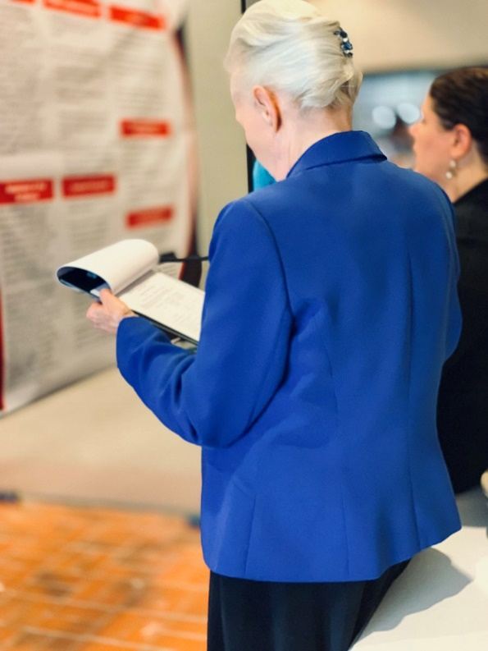Thank you to all the judges who participated: Ann Hagstrom (pictured), Laura Thomas (pictured), Grace Sun, Laura Opton (pictured), Yondell Masten (pictured), Kathy Sridaromont, and Inola Mello.

Pictured: Yondell Masten & Laura Opton

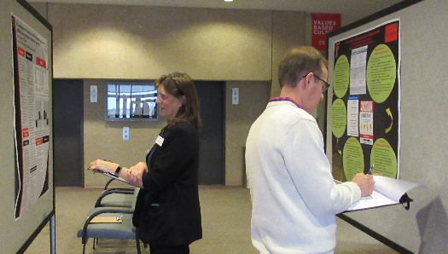

Pictured: Ann Hagstrom & Jeff Watson

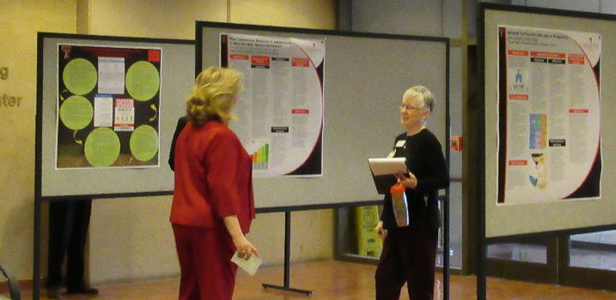

Pictured: Dr. Alyce Ashcraft & Laura Thomas