Color Your Life

Add some color to your life by eating a variety of fruits and vegetables every day. Aside from adding variety and making your plate appealing, eating different colors of fruits and vegetables adds unique nutrients to your diet. Each color contains different vitamins and minerals necessary to live a healthy life.

**How?**

To help your body get a complete range of nutrients, eat 4-5 servings per day of fruits and vegetables with varying colors.

**Portion is Key!**

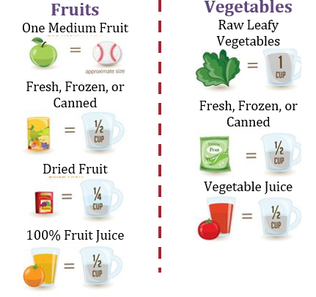

**Green**

Foods: Grapes, kiwi, broccoli, cucumbers, kale, spinach, asparagus

Benefits: Growth and development, eye health, circulation

**White**

Foods: Ginger, jicama, onion, mushrooms, garlic, potatoes, cauliflower

Benefits: Heart health, HDL cholesterol

**Blue/Purple**

|  |
| --- |
| Foods: Blueberries, figs, grapes, eggplant, beets, beans, raisins  Benefits: Healthy aging, circulation, heart health |

**Red**

Foods: Apples, strawberries, tomatoes, red peppers

Benefits: Heart health, memory, immunity

**Yellow/Orange**

Foods: Carrots, squash, lemons, bananas

Benefits: Eye health, heart health, immunity

**Nutrition Tips:**

* Make half your plate fruits and veggies
* All kinds count! - fresh, frozen, canned, dried, and 100% juice
* Make a rainbow on your plate. - fruit salad, stir fry, Mexican bowl, sandwich, or wrap
* Blend it up! – eat some veggies in a fruit smoothie

**Recipe:**

**Corn and Black Bean Salsa**

Ingredients:

* 1 can low sodium black beans, drained and rinsed
* 1 can sweet corn, drained and rinsed
* 1 can rotel
* 1 large lime
* 1 medium red onion, chopped (optional)
* Cilantro to taste (optional)

Directions:

1. Mix all canned ingredients together
2. Squeeze lime juice over salsa and mix together
3. Add red onion and cilantro to taste

Serve with tortilla chips or on top of chicken breast or fish fillets as a flavorful and nutrient packed garnish!

**Resources:**

<http://www.foodinsight.org/Eat_a_Rainbow_Functional_Foods_and_Their_Colorful_Components>

<https://www.fruitsandveggiesmorematters.org/eat-a-colorful-variety-of-fruits-and-vegetables>

<https://www.wholekidsfoundation.org/downloads/better-bites/better-bites-eat-a-rainbow.pdf>

<https://www.thatswhatchesaid.net/corn-black-bean-salsa/>

Created by: Yanci Yeater | Texas Tech University Graduate Student | Dietetic Intern | April 2019